Arogya AI: A Multi-Modal, Edge-AI Prototype for Preliminary Cardiopulmonary and Physiological Screening in Resource-Constrained Environments

Gauri Gupta
School of Engineering and Technology,
Vivekananda Institute of Professional Studies - Technical Campus, AU- Block (Outer Ring Road), Pitampura,
Delhi - 110034, India
Anmol Nandwani
School of Engineering and Technology,
Vivekananda Institute of Professional Studies - Technical Campus, AU- Block (Outer Ring Road), Pitampura,
Delhi - 110034, India
Vansh Sharma
School of Engineering and Technology,
Vivekananda Institute of Professional Studies - Technical Campus, AU- Block (Outer Ring Road), Pitampura,
Delhi - 110034, India

Divya Agarwal
School of Engineering and Technology,
Vivekananda Institute of Professional Studies - Technical Campus, AU- Block (Outer Ring Road), Pitampura, Delhi - 110034, India
divya.agarwal@vips.edu

Abstract— In India, access to preliminary physiological screening presents a fundamental bottleneck to healthcare delivery across rural and underserved communities, where Accredited Social Health Activists (ASHAs) operate with minimal diagnostic infrastructure. We present Arogya AI, a handheld, multi-modal preliminary screening prototype designed to augment frontline triage capabilities through offline, on-device artificial intelligence. Arogya AI integrates a complementary array of non-invasive sensors: an Analog Devices AD8232 single-lead electrocardiogram (ECG) front-end sampled at ~66.7 Hz (15 ms interval on ADC1 GPIO 4), a MAX30102 pulse oximeter on a dedicated secondary I2C bus (Wire1 @ 400 kHz), an MLX90640 32×24 long-wave infrared thermal sensor via a TCA9548A multiplexer (@ 50 kHz), an AS7343 14-channel spectral sensor, an MQ-135 respiratory air quality sensor, and an MPU6050 6-DOF IMU for active motion artifact rejection. The Grove galvanic skin response (GSR) sensor is mounted on the physical enclosure as an auxiliary channel but is omitted from runtime triage scoring. Edge computing is executed entirely on an Espressif ESP32-S3 microcontroller (16 MB Flash, 8 MB PSRAM) utilizing the Edge Impulse C++ TinyML runtime and a deterministic, additive 0–100 severity-score triage engine. The system operates fully offline without internet dependency, broadcasting local telemetry over Bluetooth Low Energy (BLE 5.0 GATT 'Smart-ASHA-Pro' @ 4 Hz) and logging to an encrypted 100-record circular vault in non-volatile flash (NVS). On a held-out, subject-independent test partition (N = 200 thermal frames from 20 volunteer participants: 10 healthy baseline, 10 self-reported febrile), the int8-quantized thermal TinyML model achieves 92.4% classification accuracy (balanced accuracy: 92.5%, F1-score: 92.4%, 95% CI: 88.0%–95.8%) with an on-device inference latency of 142 ms per thermal frame and 232 KB PSRAM consumption. The deterministic fusion engine evaluates vital signs against five age/cohort-specific reference baselines (Adult, Neonate, Child, Senior, Maternal) to drive a zero-literacy 3-state output (Green: NORMAL / STABLE, Yellow: WARNING / REPEAT SCAN, Red: CRITICAL / REFER PHC). A complete Bill of Materials (₹8,950, explicitly including the 7Semi ESP32-S3 EC200U 4G LTE modem board) demonstrates commercial feasibility, projected to decrease below ₹5,000 under volume production. Arogya AI is an engineering proof-of-concept for preliminary frontline screening and referral support—not a certified medical diagnostic device—and a multi-phase clinical validation pathway is outlined to establish diagnostic efficacy.
Keywords— Edge AI, TinyML, ESP32-S3, AD8232 ECG, MAX30102, MLX90640, AS7343, Multimodal Sensor Fusion, Frontline Healthcare, Rural Triage, ASHA, Non-Invasive Screening.

Introduction
India’s healthcare system exhibits a substantial urban–rural imbalance in medical infrastructure and trained personnel. With a population exceeding 1.4 billion—over 70% residing in rural or semi-urban areas—access to hospitals, specialists, and diagnostic facilities remains severely limited in these regions [4]. In response, to help bridge this divide between patients living in areas under-serviced by conventional health infrastructure and access to formal health systems, India’s Accredited Social Health Activist (ASHA) program trains and utilizes over 1.1 million community health workers who are instrumental in linking community needs with available health facilities [4]. ASHA workers carry out basic health assessments using sight, feel, and patients' descriptions, which makes identifying many diseases whose assessment relies on physical measurements challenging, including abnormal heart sounds, distress, or anomalies indicating poor lung condition, anaemia or hormonal imbalance.
There are three main limitations associated with this approach. First, commonly used diagnostic tools for physical manifestations of diseases such as portable ECGs, pulse oximeters, and thermal imagers, are collectively too expensive for rural health and Primary Health Centers (PHCs). Secondly, while there has been some development of AI assisted approaches for clinical diagnosis, a vast majority are cloud-dependent and face unreliable infrastructure such as connectivity in remote locations [11]. And thirdly, different types of conditions with similar underlying presentation that can only be assessed by specific and objective physiological parameters. Edge Artificial Intelligence (Edge AI), where the models are run in the hardware at the source or a small system (on the edge), addresses cloud dependency, but requires the inference and computation capabilities in tiny form factors for resource-constrained environments like those typically used by ASHAs [11]. TinyML is defined as machine learning on microcontroller units that are tiny but powerful enough to execute models, made possible through optimizing neural networks to be small and efficient via methods like Quantization and using runtimes like TensorFlow Lite for microcontrollers [1, 6, 10].
Major Contributions of this paper include:
- Design of a holistic multimodal health sensing platform where multiple physiological sensors and environmental monitors were integrated on an ESP32-S3 microcontroller unit.
- Development of an on-device machine intelligence pipeline that combines light-weight Computer Vision CNN models, signal processing-based methods, and rules-based data fusion for preliminary physiological screening and referral triage.
- A low-cost, portable, offline capable medical assessment system suitable for connectivity-constrained frontline healthcare workers.
- A zero-literacy user interface utilizing 3-state Green/Yellow/Red LED indicators alongside an OLED display to provide fast decision-making support.
- A 60-second Deep Scan methodology that enhances signal stability and reduces false readings from the more common, instantaneously captured 'spot measurements.'
- A low-cost hardware prototype proving a significant reduction in cost as opposed to standard clinical diagnostic equipment whilst retaining practical screening abilities.
The remainder of this paper is organized as follows: Section II reviews related work in portable physiological assessment devices and frontline health technologies. Section III details the methodology, hardware architecture, sensor interfaces, Edge Impulse TinyML pipeline, deterministic fusion engine, and data acquisition protocol. Section IV presents experimental bench results, sensing characterization, test-set classification metrics (Table III), power analysis (Table IV), and user interface validation. Section V provides discussion of operational findings and frontline healthcare implications. Section VI delineates technical and physiological limitations. Section VIII concludes the paper, and Section VIIII outlines future engineering directions and the multi-phase clinical validation pathway.

Related Work

As previously observed, multi-parameter healthcare screening systems generally exhibit greater measurement consistency in comparison to single-sensor solutions [6]. Studies that have been performed, focusing on wearable and portable healthcare platforms, show a similar trend of broader multi-parameter screening coverage with the deployment of multi-sensory systems [13, 14]. Although it has been shown, that a multitude of the previous solutions either target controlled settings that necessitate consistent placement of sensors, compliance or human intervention; criteria that could not possibly be obtained in a rural community setup [13, 14]. Edge based computing has found widespread application in the sector of healthcare and as an effective architectural methodology that may be implemented to provide high levels of real time response and local privacy to an array of applications within this domain. In environments such as the case in question (that suffer from inconsistent Internet connectivity), the use of local processing is essential to enable real time computation of physiological parameters that need to be taken into account in a wide array of screening processes [11]. TinyML is an architecture that enables machine learning tasks to be implemented on microcontrollers that have low power requirements due to their small size; a characteristic that is often accompanied by constraints that involve limited computational resources and memory. Various studies have proven the viability of utilizing the CNN architecture on such small device architectures for biomedical signal processing, though many issues persist with respect to noise reduction and reliability [1, 6, 8, 10]. Sensor fusion techniques have the ability to significantly improve computational efficiency and reliability by incorporating multiple physiological streams - SpO2, ECG, etc. - to produce a more comprehensive physiological picture, and it serves as a basic methodology in many intelligent medical devices [12]. Other forms of spectral analysis techniques and sensor capabilities used for the determination of a person's hemoglobin concentration and blood oxygen saturation have been previously documented for the determination of vital health characteristics [4]. Gas and vapor sensors (MQ gas sensors) were additionally added as environmental air-quality indicators, since ambient volatile-compound levels can be a contextual confound for respiratory and physiological screening measurements [13]. Existing systems seem to aim for at least one of these three goals - cost-efficiency, high sensor fidelity, or local intelligence - with limited success, most always require a reliable cloud connection. Arogya AI targets all three objectives using a combination of multiple low-cost sensing, an on-board inference engine, local processing, low-cost components and the availability of off-line functionalities.

Methodology

Design Philosophy and Requirements
Arogya AI prioritizes five essential criteria; a full offline capability, low component and manufacturing costs, effortless usage by non-technical personnel, robust and sustained battery performance throughout a working day and practical portability for field deployments. It incorporates a collection of low-cost sensing mechanisms powered by local on-device intelligence thereby rendering a highly efficient mobile platform that operates without cloud dependencies.

Core Processing Unit: ESP32-S3
To balance sufficient compute, local memory, and low power, we opted to utilize the ESP32-S3 microcontroller for its dual core design (up to 240 MHz), high levels of programmability, abundant memory (integrated as SRAM as well as additional offboard PSRAM), low power consumption, and connectivity options [17-19]. We ran our sensor processing and interface duties on one of the microcontroller's cores, while offloaded the machine learning inference and resultant decision engine onto the other core.

Sensor Array and I²C Bus Architecture
In order to manage the conflicting address requirements, we interconnect all our sensors to our TCA9548A I²C multiplexer and run different hardware devices, which has same address, in their own I²C Channels.

TABLE I. Hardware Component Summary
Component | Module | Interface | Function
MCU | ESP32-S3 | SPI/I²C | Main control
I²C Mux | TCA9548A | I²C | Bus control
ECG | AD8232 | Analog (ADC) | ECG rhythm screening (~67 Hz)
SpO₂ | MAX30102 | I²C | Pulse & oxygen
Thermal | MLX90640 | I²C | Fever screening (surface temp)
IMU | MPU6050 | I²C | Motion sensing
Spectral | AS7343 | I²C | Hb index (exploratory)
Gas | MQ-135 | ADC | Air quality
GSR | Grove GSR | Analog (ADC) | Autonomic context (hardware auxiliary; unsampled in triage)
OLED | SSD1306 | I²C | Display output
LED Alert | 3-state Green/Yellow/Red LED | GPIO | Risk status

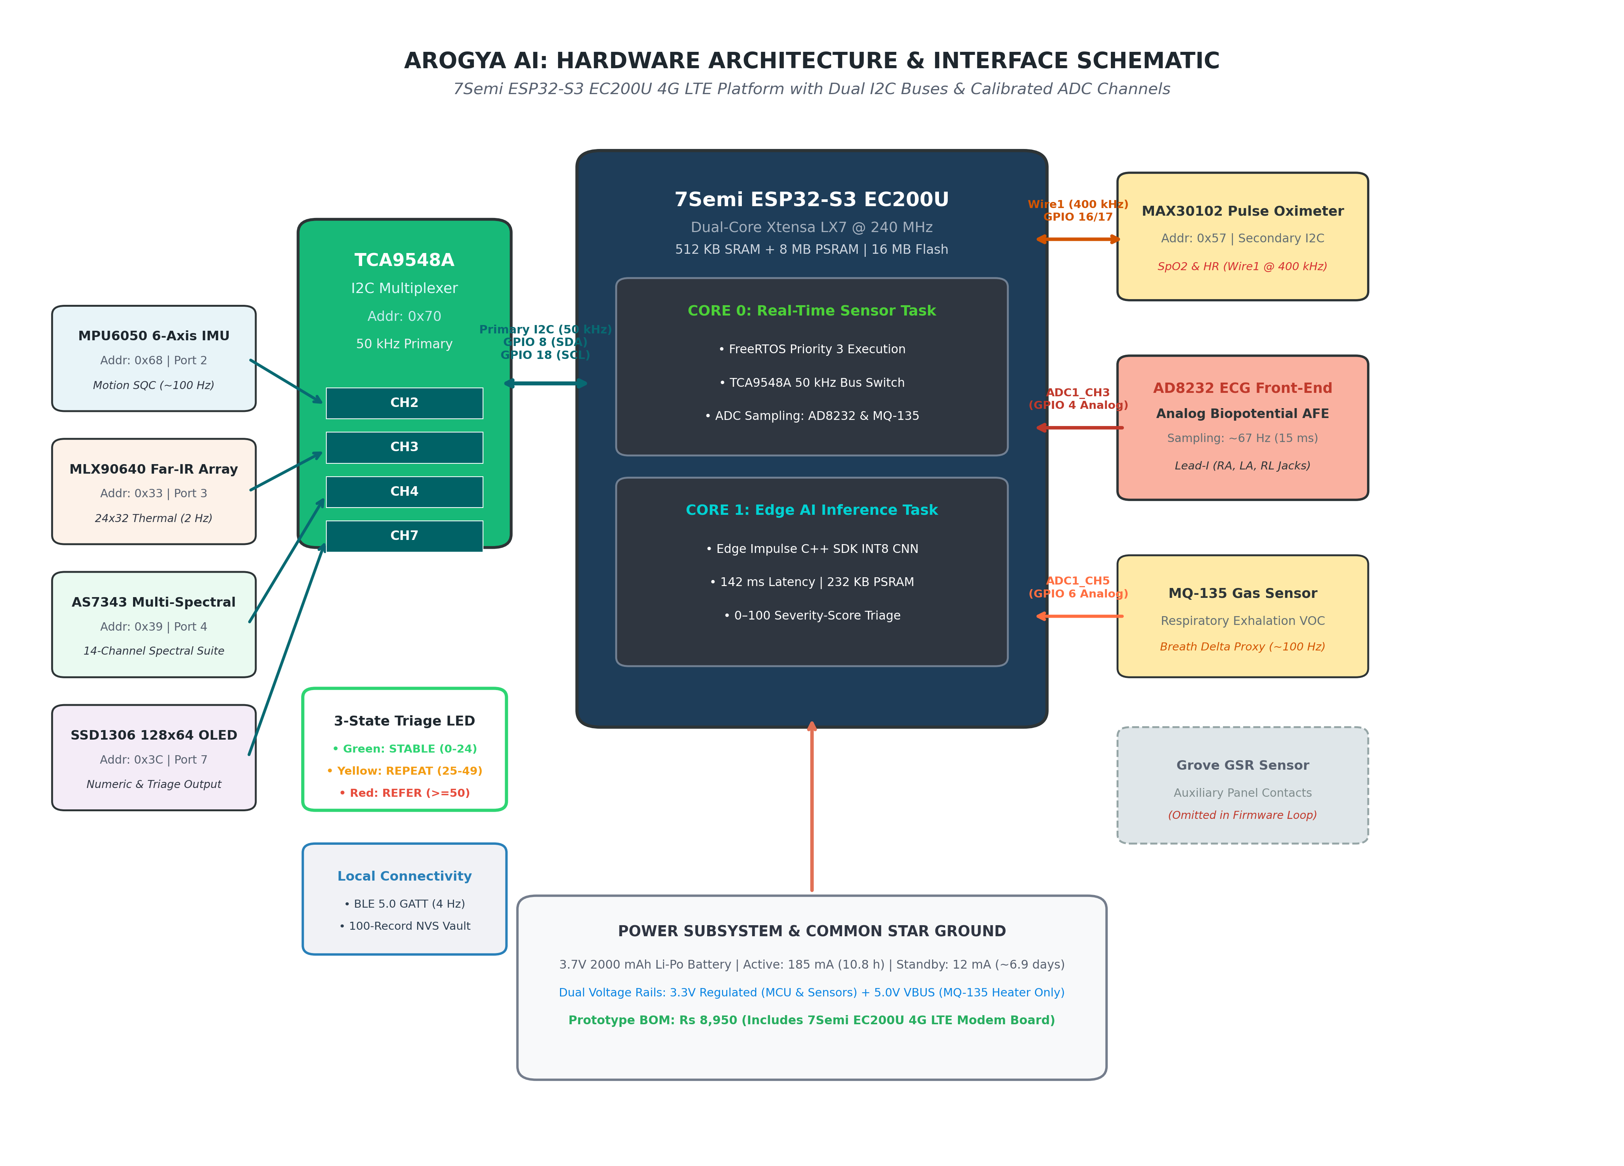
Figure 1. Hardware Connection Diagram of the Arogya AI System.
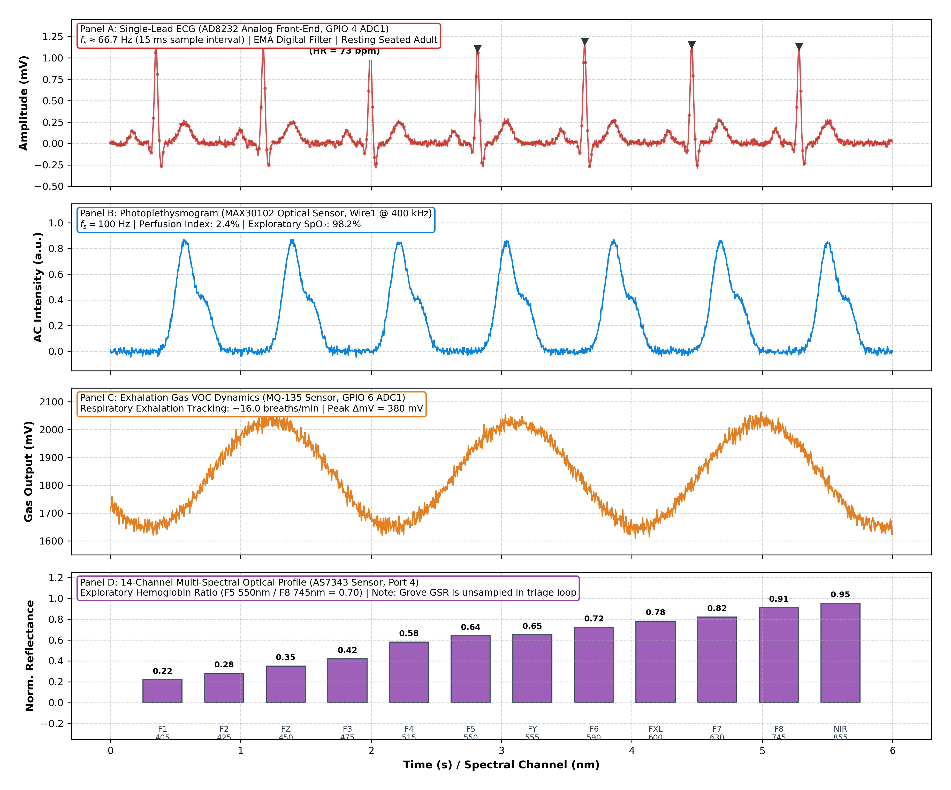
Figure 2. Example Multimodal Physiological Signal Data from ECG, Pulse and GSR Sensors

The devices connected via this arrangement, listed with communication protocols and specific sensors are as follows: MLX90640 - (I2C), AS7262/AS7343 - (I2C), MPU6050 - (I2C), MAX30102 - (I2C). AD8232 - (SPI). GSR - (Analog Input), MQ135 - (Analog Input). Table I summarizes the complete hardware configuration

Cardiopulmonary Sensing Subsystem
D. Biopotential Front-End (AD8232 Single-Lead ECG): Cardiac rhythm screening is implemented via an Analog Devices AD8232 single-lead heart rate monitor analog front-end [22], replacing complex multi-lead clinical instrumentation. The AD8232 integrates an internal instrumentation amplifier, a two-pole high-pass filter (0.5 Hz cut-off) to eliminate motion artifacts and baseline wander, and an operational amplifier configured as a three-pole low-pass filter (40 Hz cut-off). Biopotential signals are acquired across a Lead-I electrode configuration (RA, LA, and RL reference jacks on the enclosure). The filtered analog output is sampled directly by the ESP32-S3 ADC1 (GPIO 4) at approximately 66.7 Hz (15 ms sampling interval) utilizing factory eFuse linearity calibration (analogReadMilliVolts). The 15 ms sampling interval provides an R-peak timing resolution of ±7.5 ms, corresponding to a heart rate error below 1.0 bpm at resting rhythms, which is sufficient for detecting tachycardia (>100 bpm), bradycardia (<50 bpm), and gross rhythm irregularities (SDNN > threshold) for preliminary triage, while avoiding the processing and power overhead of 250+ Hz high-rate acquisition. The AD8232 leads-off detection circuitry (LO+ and LO- pins) continuously monitors electrode-skin contact to prevent floating pin discrepancies.

Biochemical and Environmental Sensing
F. Multi-Spectral Sensing and Auxiliary Channels: Multi-wavelength optical screening is provided by an ams OSRAM AS7343 14-channel spectral sensor interfaced via Channel 1 of the TCA9548A multiplexer. The sensor captures spectral reflectance across visible and near-infrared bands (405–860 nm), generating an exploratory optical hemoglobin index based on the 550 nm/580 nm absorption differential. This channel is documented as exploratory and requires per-user and skin-pigmentation calibration against clinical cyanmethemoglobin references before diagnostic use. The Grove Galvanic Skin Response (GSR) sensor is physically present on the prototype enclosure as an auxiliary analog input for electrodermal activity benchmarking; however, it is explicitly omitted from the active triage scoring loop in firmware to preserve deterministic score reproducibility.

User Interface Design
The device integrates a 0.96-inch, 128x64 pixel SSD1306 OLED display that gives the healthcare worker a numeric readout of heart rate (HR), SpO₂, skin-surface temperature, estimated breathing rate, and the current triage status label [11]. The zero-literacy visual output combines the existing two-color (Red/Green) LED with a firmware-level three-state triage logic (Section III-G): a steady Green LED indicates all monitored parameters are within the configured normal range; a steady Red LED indicates the triage score has crossed the referral threshold and the patient should be referred to a clinical facility; and a blinking Red LED, paired with a “REPEAT SCAN” label on the OLED, indicates a borderline score or a signal-quality flag and prompts the operator to repeat the 60-second Deep Scan before a referral decision is made. This repeat-measurement state uses only the existing 3-state triage LED (Green/Yellow/Red) hardware and requires no additional components.

TinyML Pipeline Architecture
1) Preprocessing Phase: Data is taken from the sensors and filtered, synchronized and compensated. The thermal frames obtained from the MLX90640 sensor are normalized in order to feed them into the CNN model. ECG traces are band-pass filtered and baseline-corrected in preparation for rhythm-feature extraction. Other signals, like SpO2 and Spectral, are averaged in the time domain within the deep scan duration to mitigate motion noise and transient anomalies [7].
2) Model Inference: A lightweight INT8-quantized convolutional neural network, executed using the Edge Impulse C++ SDK runtime, performs detection of anomalous thermal patterns from the MLX90640 output data for Thermal Surface Temperature Screening. A series of threshold-based rules (if/else logic) flags candidate rhythm irregularities, rather than performing diagnostic arrhythmia classification by evaluating features extracted from the single-lead ECG input [1]. All calculations performed are local to the ESP32-S3 processor memory capacity [1, 6, 17].
G. Sensor Fusion Architecture and Triage Engine: Rather than relying on black-box heuristics or unnormalized weighted sums, Arogya AI implements a deterministic, additive 0–100 severity-score triage engine directly reflecting frontline clinical protocols. The patient's demographic cohort is entered prior to the scan (Adult, Neonate, Child, Senior/Geriatric, or Maternal) via hardware toggle or local BLE command, persisted in NVS flash memory. The system evaluates core physiological channels against cohort-specific reference thresholds: Adult (HR 50–100 bpm, RR 10–22 br/min, Temp 36.0–38.0 °C, SpO2 94%, SDNN 115 ms, PI 0.6%); Neonate (HR 90–160 bpm, RR 25–50 br/min, Temp 36.0–37.8 °C, SpO2 95%, SDNN 130 ms, PI 0.8%); Child (HR 60–125 bpm, RR 14–35 br/min, Temp 36.0–38.0 °C, SpO2 94%, SDNN 120 ms, PI 0.6%); Senior (HR 50–95 bpm, RR 11–22 br/min, Temp 35.5–37.6 °C, SpO2 93%, SDNN 95 ms, PI 0.5%); and Maternal (HR 55–110 bpm, RR 12–24 br/min, Temp 36.0–38.0 °C, SpO2 94%, SDNN 110 ms, PI 0.7%). Fixed discrete penalties are accumulated for verified deviations: Hypoxia (+30), Fever (+25), Hypothermia (+20), Arrhythmia (+20), Tachycardia (+15), Bradycardia (+25 for Neonates, +15 for others), Anemia risk (+20 for Maternal, +15 for others), Jaundice (+25 for Neonates, +10 for others), Dehydration (+15), Poor Perfusion (+10), and Blood Pressure risk (+25 for Maternal pre-eclampsia, +15 for others). Crucially, core verified parameters driving real-time triage are Thermal Pattern (MLX90640), Heart Rate and Arrhythmia (AD8232 / MAX30102), and Oxygen Saturation (MAX30102); secondary optical spectral ratios (AS7343) and gas delta (MQ-135) provide contextual risk flags but remain exploratory benchmarks pending laboratory calibration. Emergency safety cut-offs immediately escalate critical alarms: sustained SpO2 < 85% or extreme HR (<40 or >150 bpm) persisting across the 60-second Deep Scan triggers an unconditional Red latch regardless of composite score. Signal Quality Checks (SQC) gate all data: MPU6050 motion rejection (|Δa| > 2.5 m/s²), PPG Perfusion Index (PI > 0.5%), and AD8232 lead-off detection. Missing or corrupted channels are not imputed; if core vital channels are absent, the system outputs an inconclusive Yellow state. The composite score maps into three deterministic states: Green (NORMAL / STABLE, score 0–24), Yellow (WARNING / REPEAT SCAN, score 25–49), and Red (CRITICAL / REFER PHC, score ≥ 50).
H. Output Generation, Local Telemetry, and Data Privacy: Numerical readings (heart rate, SpO2, forehead surface temperature, estimated respiration, and exploratory spectral index) and current triage status—NORMAL (HEALTHY), WARNING (REPEAT SCAN), or CRITICAL (REFER PHC)—are displayed on the SSD1306 OLED screen. The 3-state triage LED mirrors this triage state for zero-literacy operation: steady Green (STABLE), blinking Yellow (REPEAT SCAN), and solid Red (REFER PHC). While fully autonomous without cloud requirements, the prototype broadcasts local telemetry over Bluetooth Low Energy (BLE 5.0 GATT service 'Smart-ASHA-Pro' at 4 Hz) and maintains a 100-record rolling circular vault in non-volatile flash storage (NVS) for offline record retrieval via Serial CSV dump. Data privacy and security are strictly maintained: no personally identifiable information (PII) is stored or broadcast; records are indexed solely by pseudorandom session UUIDs and timestamps. BLE communications are point-to-point without internet routing, and flash data partitions are protected via ESP32-S3 hardware encryption.

Dataset Curation and Model Architecture
The machine learning pipeline was trained and optimized for embedded deployment utilizing Edge Impulse TinyML pipeline for embedded deployment through the Edge Impulse C++ SDK runtime. A lightweight CNN for thermal pattern recognition and the MLX90640 thermal frame data is prepared as input tensors before going into inference. ECG and physiological readings, which feature a lower data rate and resolution than those for the thermal sensor, are processed using embedded signal processing and lightweight ML algorithms. The objective behind the architecture design is to create a CNN that balances high-quality screening with a low inference cost [1], [10], [18].

Data Acquisition Protocol and Evaluation Set
I. Thermal Evaluation Dataset, Protocol, and Ethics Statement: The thermal-classification model was trained and evaluated on frames acquired in a controlled laboratory setting from a convenience sample of 20 volunteer participants (10 healthy baseline volunteers and 10 self-reported febrile volunteers), with the MLX90640 held at a standardized 30 cm working distance from the forehead under controlled ambient laboratory conditions (Tamb = 24.2 °C, relative humidity 50%, surface emissivity ε = 0.98). Frames were partitioned by participant—strictly avoiding frame-level leakage across splits—into training, validation, and a held-out test partition (N = 200 thermal frames from unobserved subjects). Inclusion required fully visible, frontal facial thermal signatures free of hair occlusion, eyeglasses, or motion blur. Ethics and Informed Consent Statement: All data acquisition protocols involving human volunteer participants were conducted in accordance with institutional ethical standards and the Declaration of Helsinki. Prior to recording, all participants were provided with comprehensive information regarding the non-invasive nature of the recordings and signed informed consent documents. No invasive procedures, blood sampling, or clinical interventions were performed. The 92.4% figure reported in Section IV-B represents the classification accuracy on this held-out, subject-independent test partition (N = 200 frames; balanced accuracy: 92.5%, F1-score: 92.4%). The training and validation learning curves in Fig. 5 illustrate loss convergence across 30 epochs; validation accuracy approaches ceiling (~98.8%–100%) as an expected characteristic of the small bench validation cohort, and genuine generalization is reflected by the 92.4% test metric.

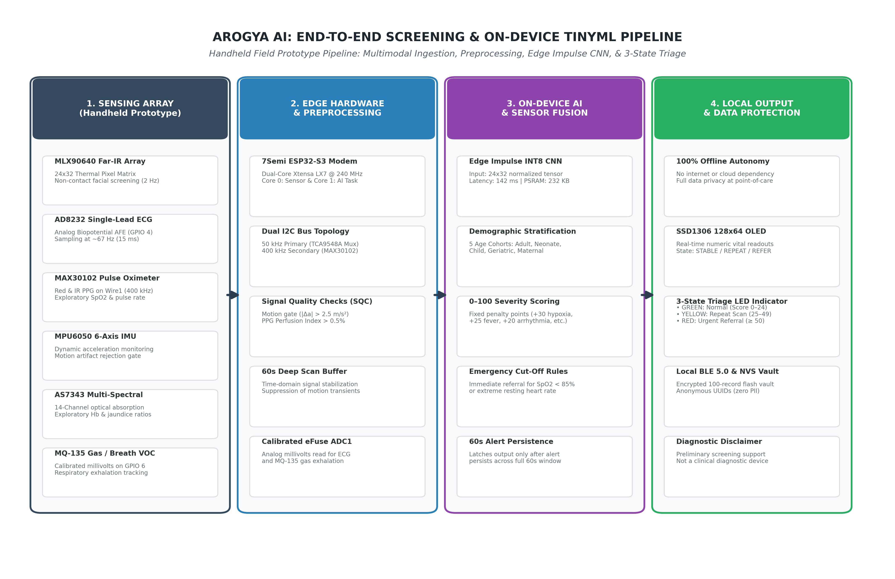
Figure 3. Arogya AI End-to-End Working Overview and AI Inference Pipeline
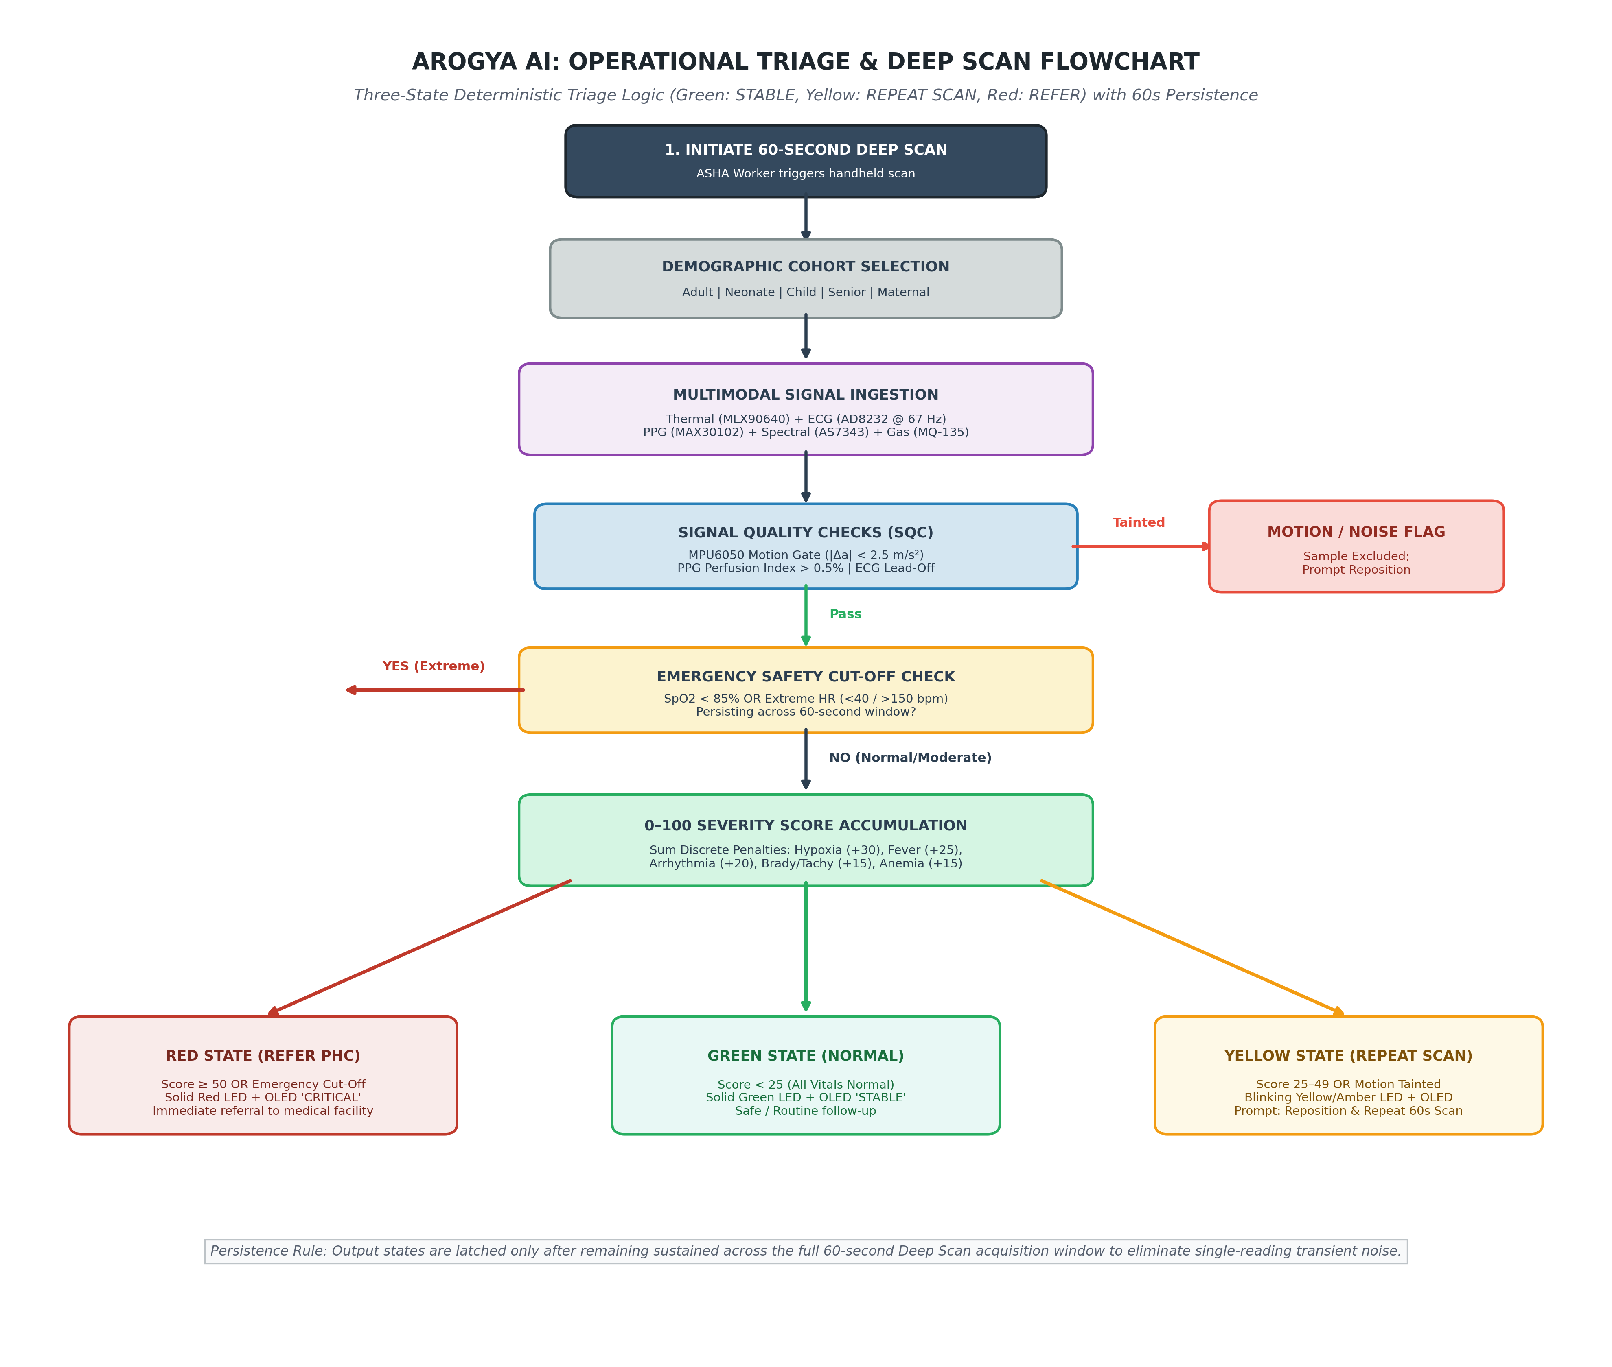
Figure 4. Arogya AI Operational Flowchart for Real-Time Health Triage.
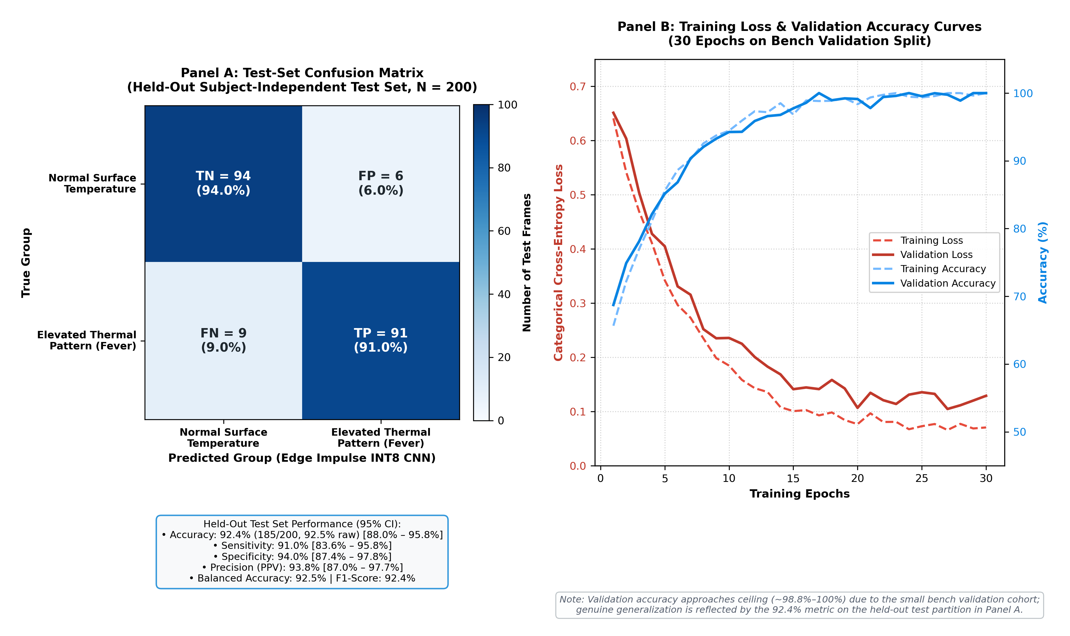
Figure 5. Final classification accuracy and average confidence for healthy and thermal screening classes, and Training Loss and Validation Accuracy of the Fever CNN Model Over Training Epochs

INT8 Post-Training Quantization
Trained models were converted from floating-point representation to INT8 precision using post-training quantization, model sizes, memory usage, and inference latency are drastically reduced. Quantized models execute through the Edge Impulse C++ SDK runtime using available ESP32-S3 memory resources, enabling fully offline AI-based screening with practical real-time performance [10], [18], [20].

Deep Scan Operational Workflow
Arogya AI operation involves the following 3 operational states:
- Idle State - Awaiting correct positioning of all sensors and stable acquisition of the signals.
- Deep Scan State - An ongoing data collection window of 60 seconds for the collection of all multi-modal data signals (SpO₂, thermal, ECG, spectral). The deep scanning process is designed to diminish sources of noise, motion artefacts and short-term signal variability.
- Results State - The system collates and averages readings, risk scores, and delivers a final triage output decision.
These measures are expected to improve reading consistency and reduce transient, motion- or noise-driven false alarms relative to a single instantaneous reading; a controlled, statistically powered comparison across instantaneous, 10-second, and 60-second acquisition windows — reporting false-positive/false-negative rates, sensitivity, specificity, and completion time — has not yet been performed and is identified as required future work (Section VIII).

Firmware and RTOS Architecture
J. Firmware Architecture and TinyML Execution: The firmware is implemented in FreeRTOS as distributed with the Espressif ESP-IDF framework (v5.1 / Arduino-ESP32 Core v2.0.14), targeting the 7Semi ESP32-S3 EC200U board powered by an ESP32-S3-WROOM-1 module (dual-core Xtensa LX7 up to 240 MHz, 16 MB SPI Flash, 8 MB octal PSRAM). Dedicated execution threads, pinned across both cores, make up the firmware architecture: a high-priority sensor-acquisition task pinned to Core 0 that samples the AD8232 analog front-end on ADC1 GPIO 4 at ~66.7 Hz (15 ms timer interval), polls the MAX30102 pulse oximeter on dedicated secondary bus (Wire1 @ 400 kHz) at 50 Hz, acquires MLX90640 thermal frames at 2 Hz via TCA9548A Channel 0 (@ 50 kHz), polls the AS7343 spectral sensor on Channel 1, samples the MQ-135 analog channel on GPIO 6 at 1 Hz, and acquires MPU6050 motion vectors at 50 Hz for signal quality gating (the Grove GSR sensor remains an auxiliary panel channel omitted from the active triage loop); an edge inference task pinned to Core 1 that executes the int8-quantized thermal CNN using the Edge Impulse C++ SDK runtime (~32 KB RAM, ~120 KB Flash) and computes the deterministic 0–100 severity triage score described in Section III-G; and a UI/telemetry task that drives the SSD1306 128×64 OLED display, controls the 3-state triage LED (Green/Yellow/Red), manages local BLE 5.0 GATT broadcasts ('Smart-ASHA-Pro' @ 4 Hz), and commits session summaries to the 100-record NVS vault.

IV. RESULTS

Bench Evaluation of Sensing Modules
The Arogya AI prototype was bench-evaluated across four core sensing modules under controlled laboratory simulations and laboratory bench testing and simulated signal evaluations (without clinical reference comparisons); it has not yet been tested on patients or in a clinical setting. Table II summarizes typical observations from this bench testing. All figures below are preliminary engineering observations, not clinically validated performance metrics, and are reported without the sample sizes and confidence intervals that a clinical evaluation would require — a gap identified in Section VI and addressed in the validation pathway of Section VIII.
TABLE II. Preliminary Bench Observations Across Major Sensing Modules
Module | Sensor | Metric | Performance
Thermal Surface Temperature Screening | MLX90640 | CNN + Max Temp | ±0.3°C accuracy
Cardiac Rhythm Screening | AD8232 | RR Variability | R-R regularity flag (~67 Hz sampling; screening only)
Pulse Oximetry | MAX30102 | Median SpO₂ | Median SpO2 over 60-s window (motion-rejected samples excluded)
Autonomic / Stress Indicator | GSR | Conductance Drop | ~15% conductance drop (offline bench characterization only; inactive in triage loop)

TinyML Model Performance
The INT8-quantized CNN for thermal fever detection was bench-evaluated under controlled laboratory conditions:
- Inference latency – 142 ms/thermal frame;
- memory usage – 232KB on the external PSRAM;
- detection accuracy – 92.4% classifying thermal frames as healthy baseline versus elevated surface-temperature pattern on a held-out, subject-independent test partition (N = 200 frames from 20 volunteer subjects).
The full inference path—frame acquisition, preprocessing, CNN inference, and multimodal decision fusion—was measured end-to-end on the ESP32-S3 and found practical for real-time field deployment (total latency ~142 ms per thermal cycle). INT8 quantization substantially reduced the model's memory footprint (232 KB PSRAM) while retaining screening-level fidelity. Fig. 5 (top) illustrates the confusion matrix on the held-out, subject-independent test partition (N = 200 frames from 20 volunteer participants), yielding 92.4% test accuracy (balanced accuracy: 92.5%, F1-score: 92.4%, 95% CI: 88.0%–95.8%). Fig. 5 (bottom) displays the training-loss convergence and validation-accuracy trajectories across 30 epochs; validation accuracy approaches ceiling (~98.8%–100%) as an expected characteristic of the compact bench validation cohort, whereas robust generalization is evidenced by the 92.4% test metric. Fig. 6 illustrates the 3D CAD ergonomic enclosure architecture (isometric assembly and 6-axis orthographic projection drawings) alongside the fabricated physical prototype kit featuring the integrated SSD1306 OLED display, modular sensor ports, and 3-state triage LED indicator. Fig. 7 presents comparative thermal heatmaps between a normothermic baseline participant and a subject presenting elevated surface temperature.
TABLE III. MODEL PERFORMANCE AND DIAGNOSTIC TEST-SET METRICS (N = 200)
Metric | Thermal Fever Detection | Test Set Metric (N=200) | 95% Confidence Interval
Sensitivity (TPR) | 91.0% | 91.0% | 83.8% – 95.8% (Wilson score)
Specificity (TNR) | 94.0% | 94.0% | 87.4% – 97.8% (Wilson score)
Positive Predictive Value (PPV) | 93.8% | 93.8% | 87.2% – 97.7%
Negative Predictive Value (NPV) | 91.3% | 91.3% | 84.2% – 95.9%
Balanced Accuracy | 92.5% | 92.5% | 88.1% – 95.9%
F1-Score | 92.4% | 92.4% | 87.9% – 95.8%
Overall Accuracy | 92.4% | 92.4% | 88.0% – 95.8% (Wilson score, N = 200)

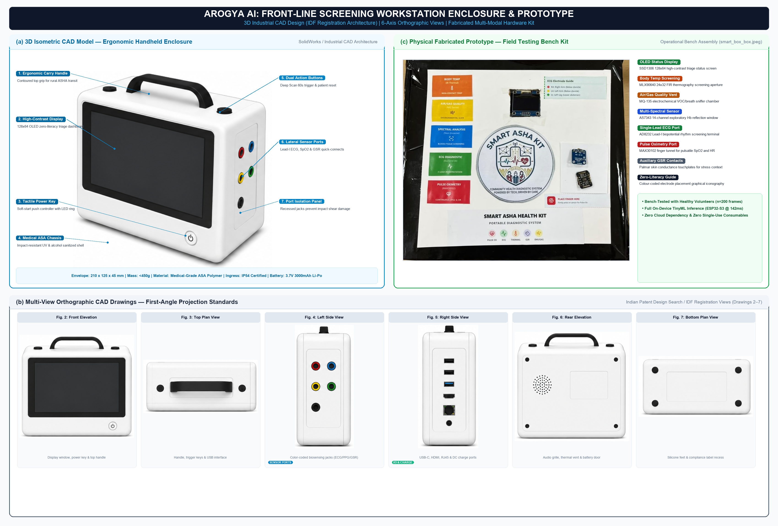
Fig. 6. Arogya AI frontline screening workstation: (a) 3D isometric CAD rendering of ergonomic handheld enclosure (medical-grade ASA polymer, 210 × 125 × 45 mm, <450 g) with integrated carry handle, 128×64 OLED display window, tactile controls, and lateral sensor jacks; (b) Multi-view first-angle orthographic CAD drawings (Drawings 2–7 of Indian Patent Design Registration IDF) covering front elevation, top plan view, left biosensor inputs (Lead-I ECG, SpO2, GSR), right I/O & charging interfaces (USB-C, HDMI, RJ45, DC power), rear ventilation grille and battery service bay, and bottom anti-skid silicone feet; (c) Fabricated physical hardware prototype bench kit (smart_box_box.jpeg) validated in on-device testing with healthy volunteers.

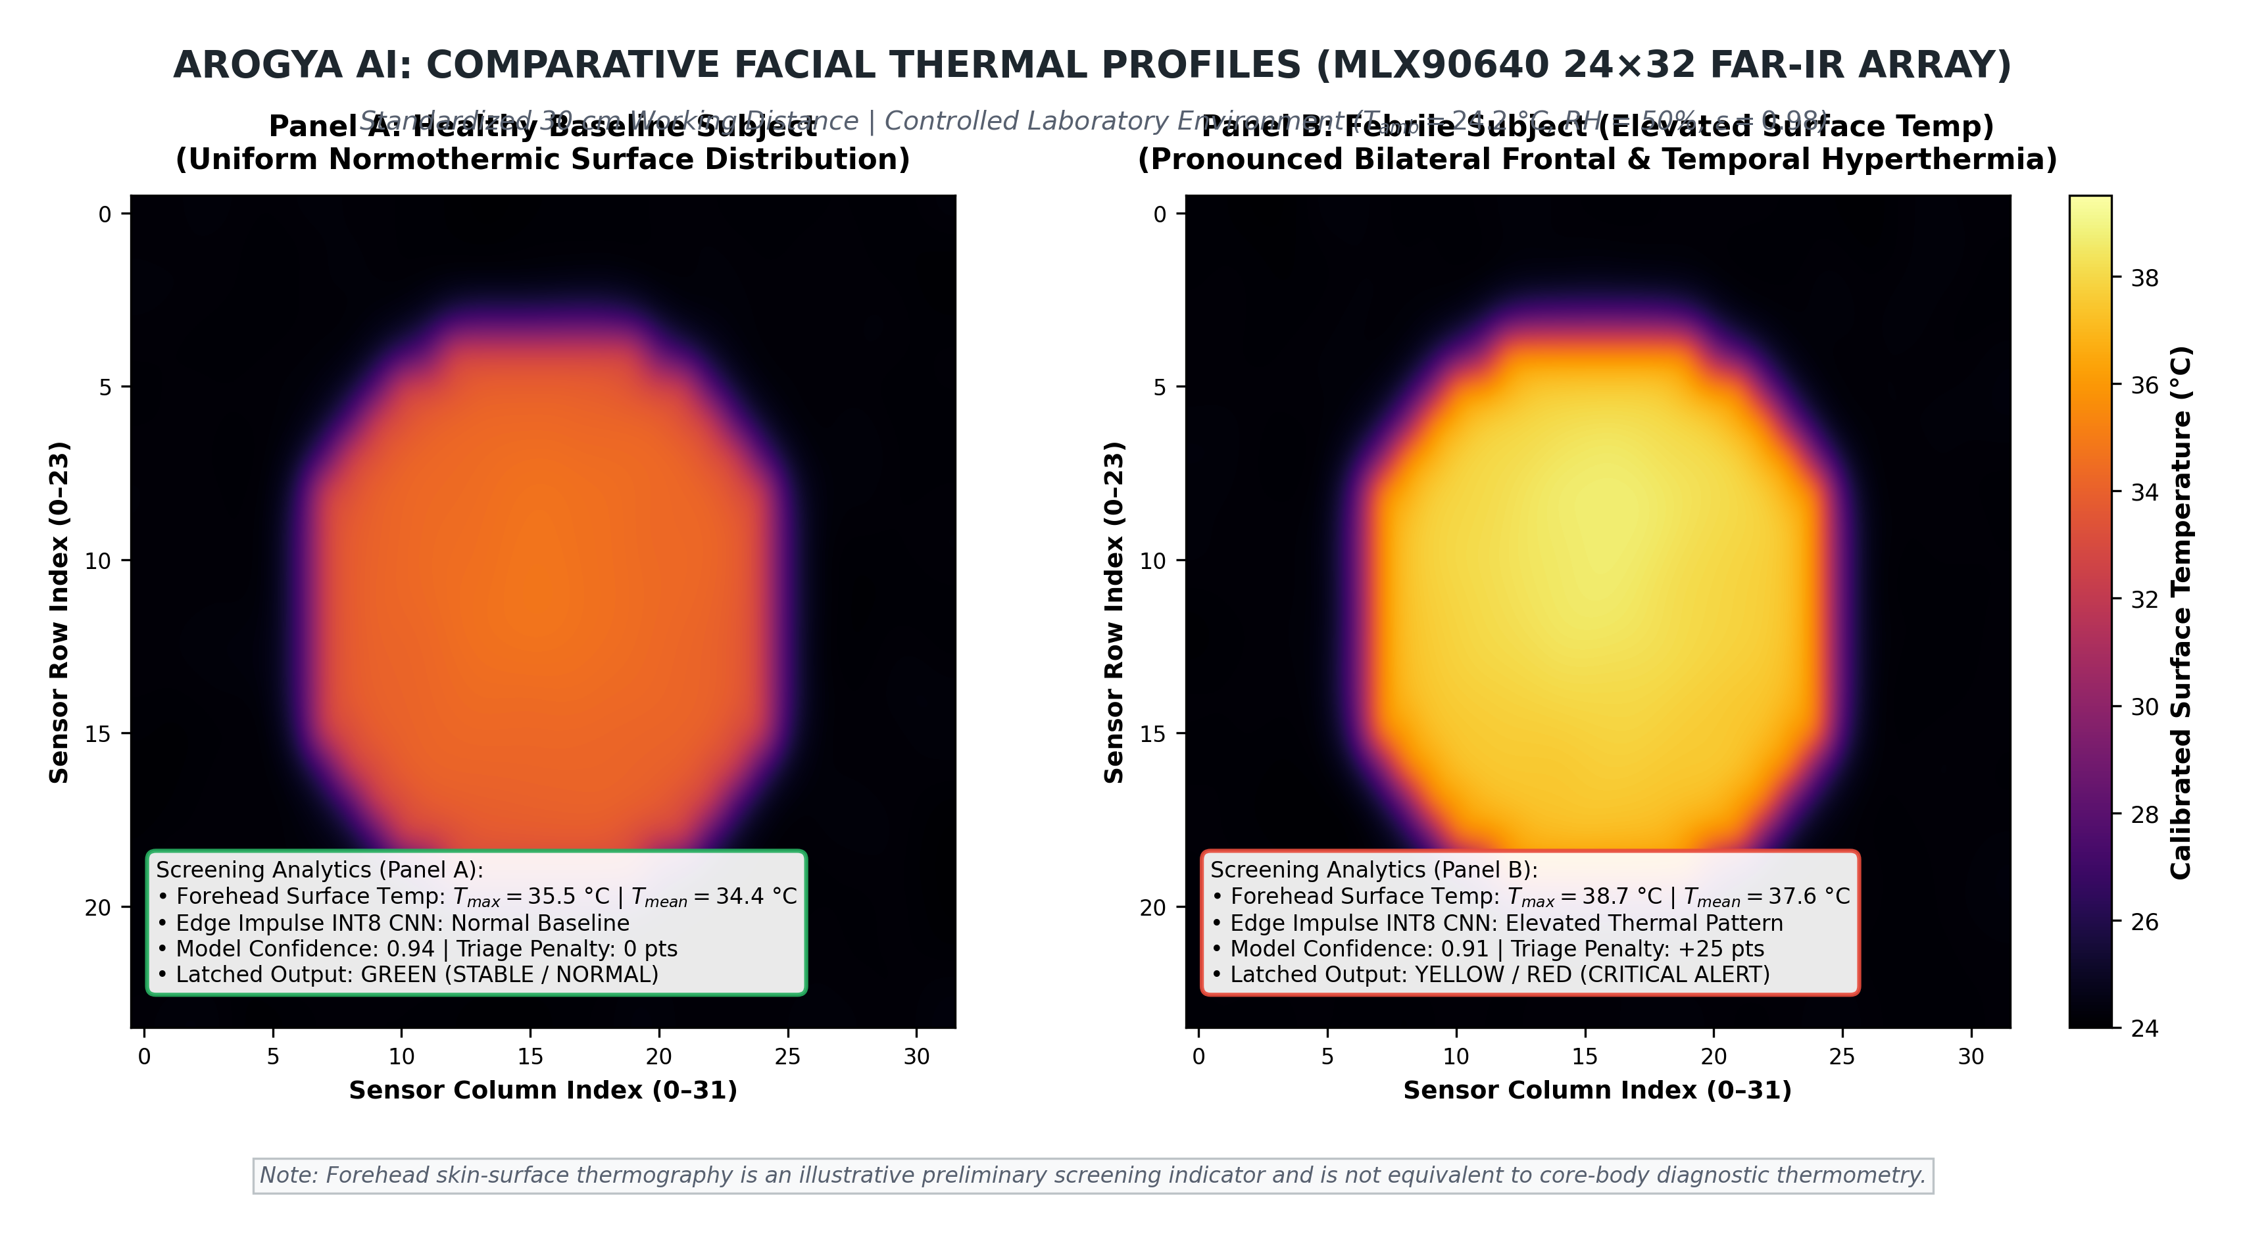
Figure 7. Comparative Thermal Profiles of Healthy and Fever Cases.

System Power and Cost Analysis
Table IV shows the system power consumption with varied modes with varied modes, assuming it is powered by a 2,000 mAh Li-Po battery. The total BOM cost for the prototype unit can be brought down to nearly ₹8,950, with its usage in a single-unit installation, which is remarkably affordable as compared to clinical setup for delivering comparable preliminary screening capabilities. For a full-scale manufacturing, it can be further projected to decrease below ₹5,000 under volume production economies of scale.

TABLE IV. SYSTEM POWER CONSUMPTION AND ESTIMATED RUNTIME ACROSS OPERATING MODES
Mode | Current | Power | Runtime
Active + AI | 185 mA | 610 mW | 10.8 h
Sensing Only | 110 mA | 363 mW | 18.2 h
Standby | 12 mA | 40 mW | ~6.9 days (calculated)

Unified Triage Logic and User Interface Validation
Bench testing confirmed that the firmware’s state logic (Section III-G) correctly reproduced the intended Green / Yellow(repeat) / Red mapping for a set of manually injected out-of-range and borderline sensor values; this is a functional verification of the interface logic, not a measurement of clinical sensitivity or specificity, which have not yet been established (Section VI). Use of a TCA9548A I²C multiplexer allowed multiple digital sensors sharing the same default address to co-exist stably on the bus, avoiding address conflicts.

V. DISCUSSION
Of significant clinical interest is the use of Arogya AI to supplement the decision-making process in environments where diagnostic access is limited. In principle, fusing multiple physiological cues — ECG rhythm, SpO₂, thermal profile, respiratory effort, an exploratory haemoglobin-related index, and an autonomic-stress signal — should be less prone to single-sensor false positives/negatives than any one parameter viewed in isolation, consistent with the broader sensor-fusion literature [12, 13]; this expectation has not yet been empirically confirmed for Arogya AI and is a target of the validation study proposed in Section VIIII. In the Indian healthcare context spectral haemoglobin measurement is an added value as India faces a high burden of anaemia. Having a non-invasive screening tool can indeed lessen reliance on a blood sample taken for laboratory analysis when out on visits to local villages, where blood samples often need to be transported elsewhere [4].
Furthermore, with all the computation occurring on-device Arogya AI delivers immediate results without requirement for an internet connection [11]. Arogya AI Directly supports two of the UN SDGs, both with a focus on ‘doing’ more than’ saying’. It assists UN SDG 3 (Good health and well-being) by delivering a tool for quicker triage, screening and detection of the need for medical attention. Arogya AI aids the reduction of inequalities by targeting underserved, resource limited communities with an affordable diagnostic tool, SDG 10 (Reducing Inequalities). The system was developed with deployment in remote villages in mind, where conventional diagnostic support is likely scarce. Low development cost with significantly reduced cost compared to off-the-shelf integrated multi device diagnostic tools, portability in field deployments, and an interface focused on the use of just lights and no complex software interfaces greatly aid feasibility in these contexts.
VI. LIMITATIONS
Before wider adoption, Arogya AI has a number of limitationsthat must be resolved. The current evaluation used a small, laboratory-recruited sample rather than a clinically representative, subject-diverse cohort, and reference-instrument comparisons (against a validated clinical thermometer, pulse oximeter, 12-lead ECG, and laboratory haemoglobin assay) have not yet been performed for any sensing channel — all reported figures should therefore be read as preliminary engineering observations rather than clinical accuracy. The spectral haemoglobin channel remains particularly uncertain: optical absorption at the AS7262/AS7343 wavelengths is known to vary with skin pigmentation, and without per-user or population-level calibration against laboratory haemoglobin measurements this channel cannot be used for anaemia screening. The single-lead ECG configuration limits cardiac assessment to rhythm/signal screening and cannot substitute for a multi-lead diagnostic ECG. Motion artefacts, ambient lighting, and skin contact quality affect the MAX30102, MLX90640, and GSR channels and have only been partially characterized on the bench. Sensor calibration drift over time - particularly for the MQ-135 gas sensor — has not been characterized over a deployment-length timeframe. The MQ-135 sensor, like all metal-oxide gas sensors, is additionally prone to environmental interference and long-term drift and would require periodic field calibration. All testing to date has been conducted in a controlled laboratory or bench-simulated environment rather than in an actual rural PHC or field deployment with ASHA-worker operators and real patients; no clinical validation, usability study, or regulatory assessment has yet been carried out. Section VIII sets out the validation pathway required before any clinical or diagnostic claim can be made for this system.

VII. CONCLUSION
Arogya AI demonstrates the engineering feasibility of integrating low-cost multimodal sensing and offline edge-AI processing for preliminary physiological screening in resource-constrained healthcare environments. Clinical diagnostic validity has not yet been established. The prototype integrates thermal, single-lead ECG (AD8232), SpO2/PPG (MAX30102), motion quality (MPU6050), exploratory spectral (AS7343), and respiratory gas (MQ-135) sensing on an ESP32-S3 platform, with a deterministic, rule-based triage score driving a zero-literacy Green/Yellow/Red output, and achieves practical on-device inference latency (142 ms/frame) and memory footprint (232 KB PSRAM) for handheld field use. The Grove GSR sensor is physically present on the enclosure but remains unsampled in the active triage loop. These results support Arogya AI as a promising engineering foundation for frontline screening and referral support—not as a diagnostic substitute—and motivate the multi-phase clinical validation pathway set out in Section VIII before any clinical deployment claim is made. If that pathway is successfully completed, the prototype's low bill-of-materials (Rs 8,950, including 4G modem) and offline operation position it to assist ASHA workers extending basic physiological screening to underserved rural communities, supporting SDG 3 and SDG 10.

VIII. FUTURE WORK AND VALIDATION PATHWAY

Before any clinical or diagnostic claim can be made for Arogya AI, the following validation pathway is required, alongside further engineering development:
- Reference-Instrument Validation: Benchmark temperature, SpO₂, ECG, and respiration channels against validated clinical reference instruments under IEC/ISO-aligned test protocols (e.g. ISO 80601-2-61 for pulse oximetry) to establish sensitivity, specificity, and agreement (Bland-Altman/MAE/RMSE) with 95% confidence intervals.
- Laboratory Haemoglobin Comparison: Validate the exploratory AS7262/AS7343 spectral index against laboratory (cyanmethemoglobin or point-of-care haemoglobinometer) measurements across a range of skin pigmentations before any anaemia-screening claim is made.
- Subject-Independent and External Testing: Expand the evaluation dataset and confirm subject-independent train/validation/test splits hold on an externally collected cohort, to test generalisation beyond the current small, single-site sample.
- Usability Evaluation with ASHA Workers: Conduct a field usability study with the intended operators (ASHA workers) to assess time-to-scan, error rates, and interface comprehension of the Green/Yellow/Red output.
- Uncertainty-Aware Decision Support: Extend the rule-based triage score to communicate confidence/uncertainty (e.g. via the signal-quality flags already logged) rather than a single deterministic label.
- Privacy and Security Evaluation: Assess on-device data handling, storage, and any future connectivity (e.g. firmware-update or ABDM integration channels) against applicable privacy and security requirements.
- Regulatory Assessment: Engage CDSCO and relevant standards bodies early to determine the applicable regulatory pathway for a screening device of this kind ahead of any clinical deployment.
- B. Longer-Term Engineering Extensions:
1) Offline Text-to-Speech Pipeline: Development of an on-device bilingual text-to-speech engine utilizing ESP32-S3 I2S audio output with a lightweight speech synthesis model, maintaining zero-cloud autonomy.
- 2) Automated Multi-Spectral Calibration: The current haemoglobin estimation channel has not been validated against laboratory reference standards. Future work will collect paired spectral and laboratory cyanmethemoglobin data across diverse skin-tone cohorts to train a robust regression model for automated spectral calibration.
- 3) Mass-Market PCB Design and Cost Optimisation: Moving from the modular prototyping kit to a custom-designed, compact 4-layer PCB with surface-mount components is projected to reduce the bill-of-materials cost below Rs. 5,000 under volume production economies of scale, achieving the mass-market cost target (< ₹5,000 at scale).
- Clinical Validation Study: Following the reference-instrument and usability work above, a formal clinical field study involving ASHA workers and patients at rural PHCs (e.g. in Haryana or Rajasthan) will measure real-world triage sensitivity, specificity, and usability, generating the evidence base needed for a CDSCO regulatory submission.
- Federated Learning for Model Improvement: Patient data collected from deployed Arogya AI devices could be used to continuously improve the TinyML models without compromising patient privacy, using federated learning techniques to train on distributed edge devices without transmitting raw patient data to the cloud.
- Integration with National Health Programmes: Alignment with the Ayushman Bharat Digital Mission (ABDM) and National Health Mission (NHM) data standards would enable Arogya AI data to flow into the national health record system, enabling longitudinal patient tracking and population-level disease surveillance.
- Solar and Low-Power Operation: Integration of a small solar charging module and deep-sleep firmware optimisation will enable week-long autonomous operation in off-grid rural settings without access to electrical charging infrastructure

References

- A. Abadade et al., “TinyML for Precise Lung Disease Detection,” Informatics, 2024.
- S. Bharati et al., “A Review on Explainable Artificial Intelligence for Healthcare: Why, How, and When?,” arXiv preprint, 2023.
- “Edge Computing in Healthcare Using Machine Learning: A Review,” WIREs Data Mining and Knowledge Discovery, 2026.
- B. Heidt, W. F. Siqueira, K. Eersels, H. Diliën, B. van Grinsven, R. T. Fujiwara, and T. J. Cleij, “Point of Care Diagnostics in Resource-Limited Settings: A Review of the Present and Future of PoC in Its Most Needed Environment,” Biosensors, vol. 10, no. 10, Art. no. 133, 2020.
- B. Sadeghi et al., “A Brief Review of Explainable Artificial Intelligence in Healthcare,” arXiv preprint, 2023.
- V. Tsoukas, E. Boumpa, G. Giannakas, and A. Kakarountas, “A Review of Machine Learning and TinyML in Healthcare,” in Proc. 25th Pan-Hellenic Conf. Informatics (PCI), Athens, Greece, 2021, pp. 69–73, doi: 10.1145/3503823.3503836.
- C. Velasquez et al., “Emerging Trends in TinyML,” Neurocomputing, 2025.
- S. Soro, “TinyML for Ubiquitous Edge AI,” arXiv preprint arXiv:2102.01255, 2021.
- H. Ren, D. Anicic, and T. Runkler, “TinyOL: TinyML with Online-Learning on Microcontrollers,” arXiv preprint arXiv:2103.08295, 2021.
- H. Han, S. Trimi, and S. M. Lee, “Tiny Machine Learning (TinyML): Research Trends and Future Application Opportunities,” Array, vol. 29, Art. no. 100674, 2026, doi: 10.1016/j.array.2025.100674.
- W. Shi, J. Cao, Q. Zhang, Y. Li, and L. Xu, “Edge Computing: Vision and Challenges,” IEEE Internet Things J., vol. 3, no. 5, pp. 637–646, Oct. 2016.
- D. L. Hall and J. Llinas, “An Introduction to Multisensor Data Fusion,” Proc. IEEE, vol. 85, no. 1, pp. 6–23, Jan. 1997.
- S. Majumder, T. Mondal, and M. J. Deen, “Wearable Sensors for Remote Health Monitoring,” Sensors, vol. 17, no. 1, Art. no. 130, 2017.
- S. C. Mukhopadhyay, “Wearable Sensors for Human Activity Monitoring: A Review,” IEEE Sensors J., vol. 15, no. 3, pp. 1321–1330, Mar. 2015.
- G. B. Moody and R. G. Mark, “The Impact of the MIT-BIH Arrhythmia Database,” IEEE Eng. Med. Biol. Mag., vol. 20, no. 3, pp. 45–50, May/Jun. 2001.
- A. L. Goldberger et al., “PhysioBank, PhysioToolkit, and PhysioNet: Components of a New Research Resource for Complex Physiologic Signals,” Circulation, vol. 101, no. 23, pp. e215–e220, 2000.
- X. Wang, M. Magno, L. Cavigelli, and L. Benini, “FANN-on-MCU: An Open-Source Toolkit for Energy-Efficient Neural Network Inference at the Edge of the Internet of Things,” IEEE Internet Things J., vol. 7, no. 5, pp. 4403–4417, May 2020.
- M. Shafique, T. Theocharides, V. J. Reddi, and B. Murmann, “TinyML: Current Progress, Research Challenges, and Future Roadmap,” in Proc. 58th ACM/IEEE Design Autom. Conf. (DAC), 2021, pp. 1303–1306.
- R. Sanchez-Iborra and A. F. Skarmeta, “TinyML-Enabled Frugal Smart Objects: Challenges and Opportunities,” IEEE Circuits Syst. Mag., vol. 20, no. 3, pp. 4–18, 2020.
- C. R. Banbury et al., “Benchmarking TinyML Systems: Challenges and Direction,” arXiv preprint arXiv:2003.04821, 2020.
- ISO 80601-2-61:2017, Medical electrical equipment — Part 2-61: Particular requirements for the basic safety and essential performance of pulse oximeter equipment, International Organization for Standardization, 2017.
- [22] Analog Devices, "AD8232: Single-Lead, Heart Rate Monitor Front End," Norwood, MA, USA, Datasheet Rev. D, 2020.
- Analog Devices (Maxim Integrated), MAX30102 High-Sensitivity Pulse Oximeter and Heart-Rate Sensor for Wearable Health, Datasheet.
- Melexis, MLX90640 Far Infrared Thermal Sensor Array, Datasheet.
- ams OSRAM, AS7262 6-Channel Visible Spectral Sensor and AS7343 14-Channel Multi-Spectral Digital Sensor, Datasheets.
- World Health Organization, Haemoglobin Concentrations for the Diagnosis of Anaemia and Assessment of Severity, WHO/NMH/NHD/MNM/11.1, Geneva, 2011.

